**NAME: ALISHBA ZAINAB**

**ROLL NO: 23-BSE-006**

**SUBMITTED TO : SIR SHOAB**

**LAB 3**

Task 1

**Handling Local and Remote Commit Conflicts (Pull vs Pull --rebase)**

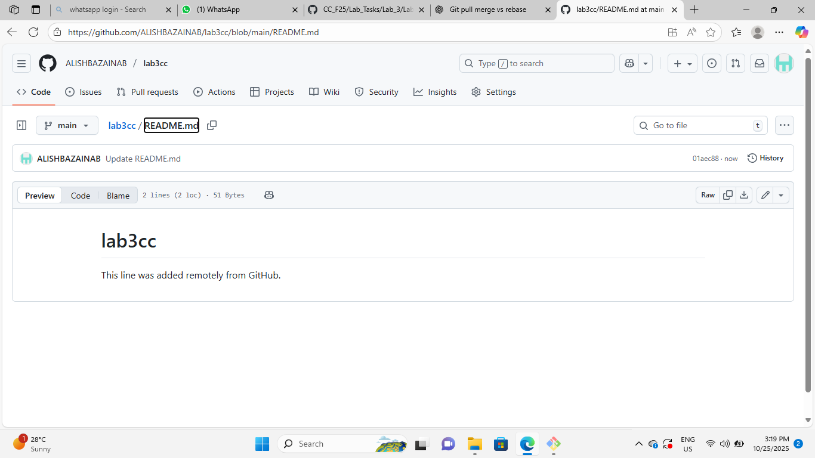

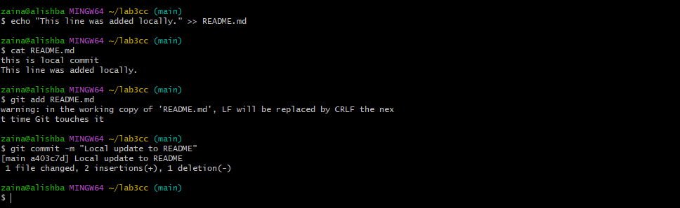

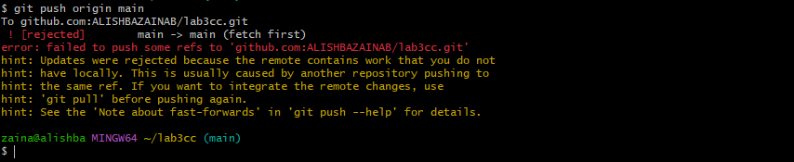

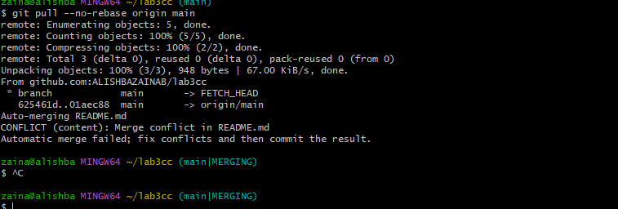

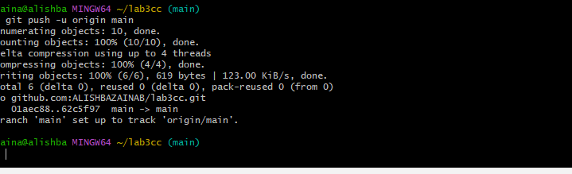

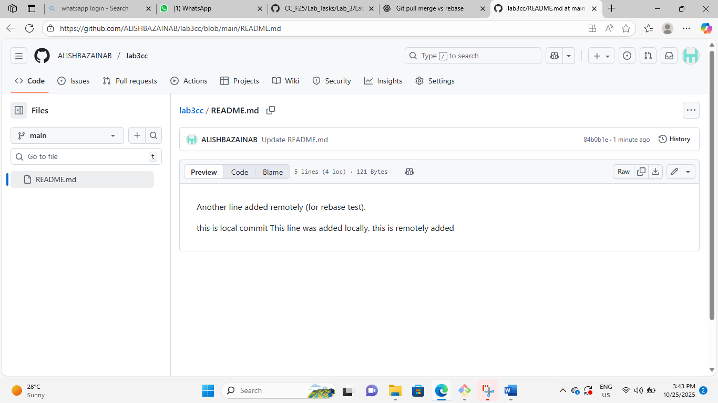

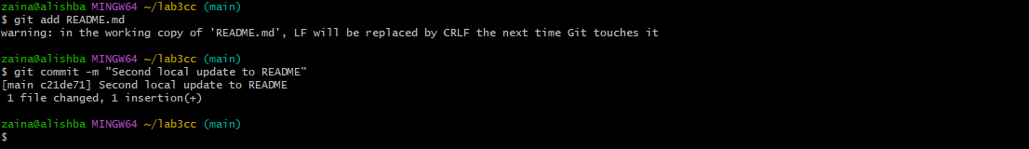

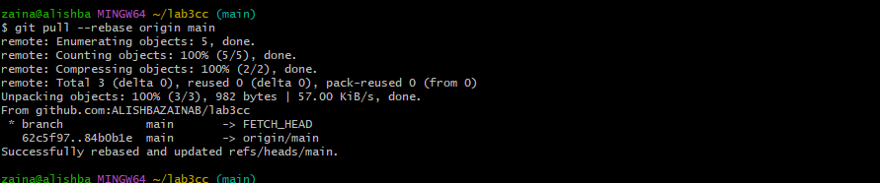

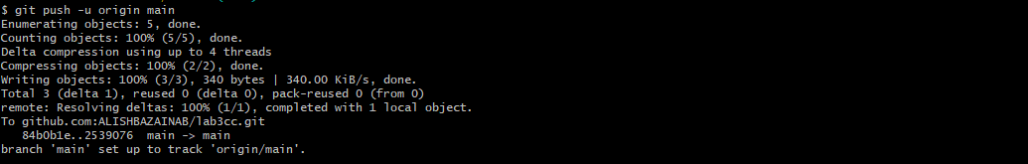

Task 2

**Creating and Resolving Merge Conflicts Manually**

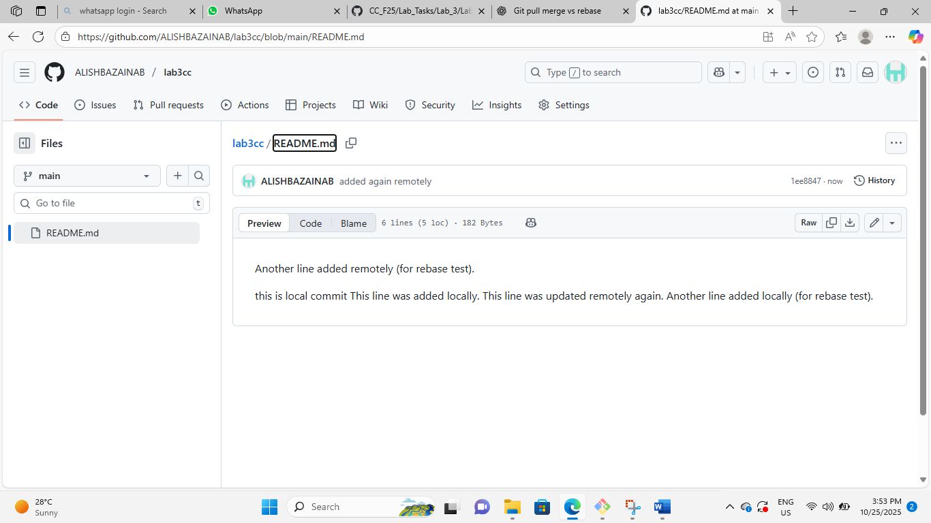

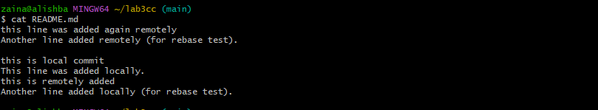

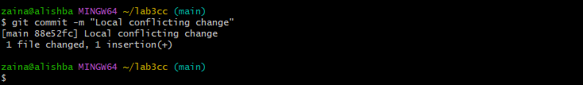

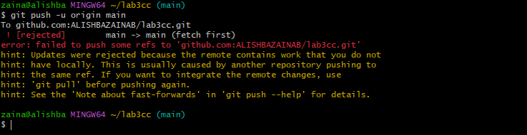

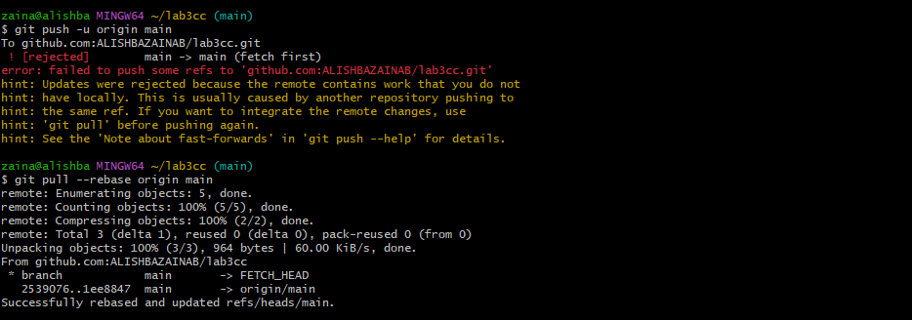

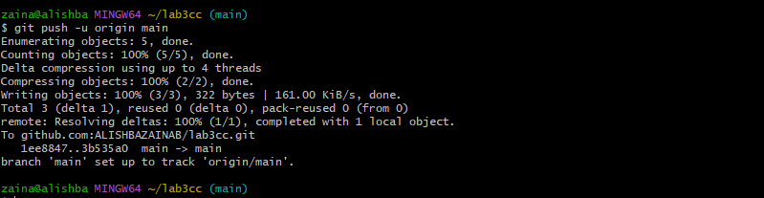

Task 3

**Managing Ignored Files with .gitignore and Removing Tracked Files**

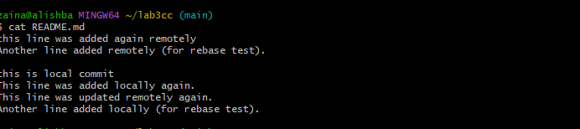



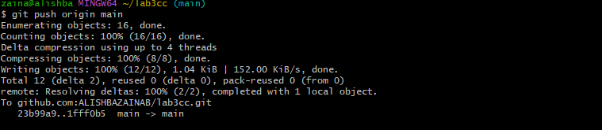

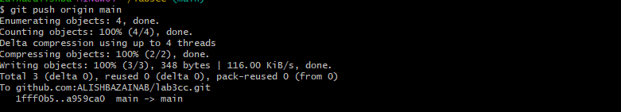

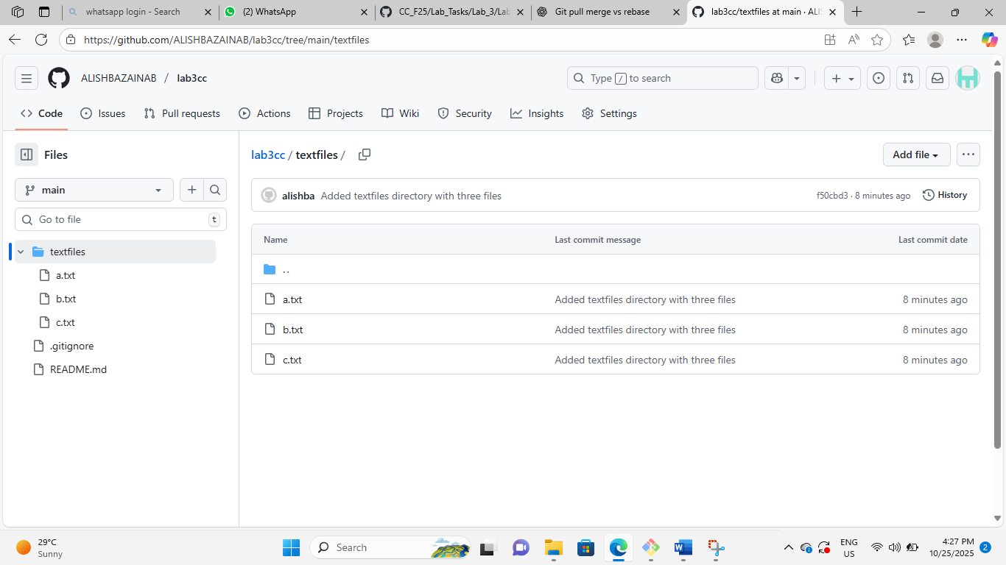

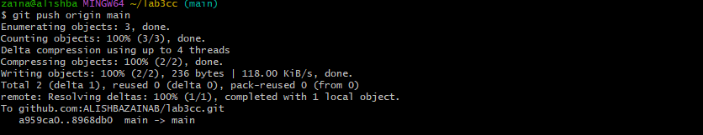

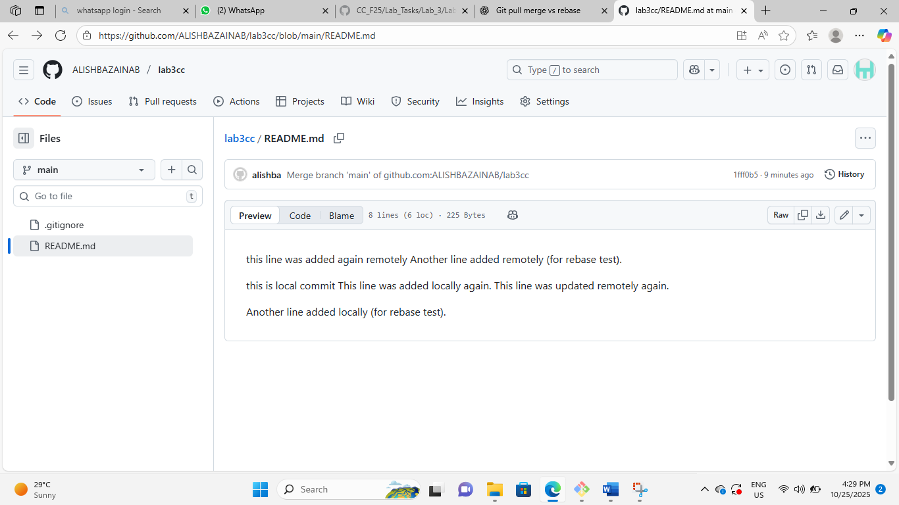

Task 4

**Create Temporary Changes and Use git stash**







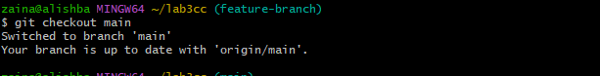

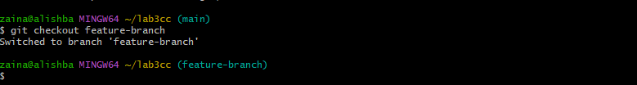

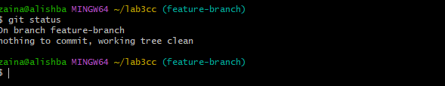

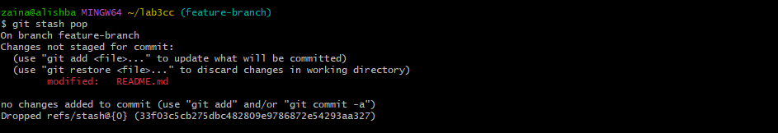

Task 5

**Checkout a Specific Commit Using git log**

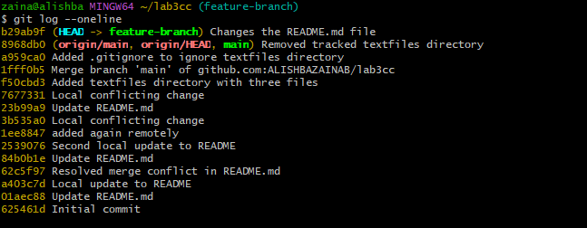

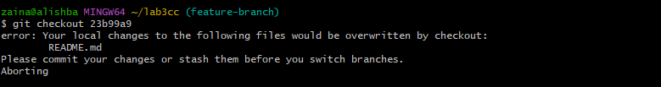

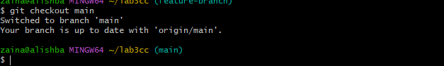

Task 6

**Resetting Commits (Soft vs Hard Reset) (With Verification Steps)**

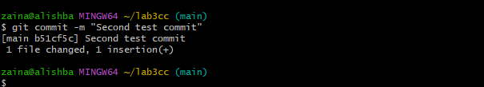

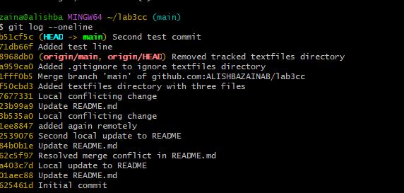

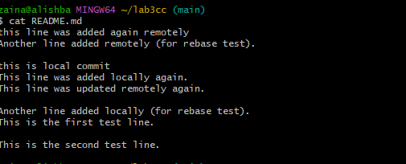

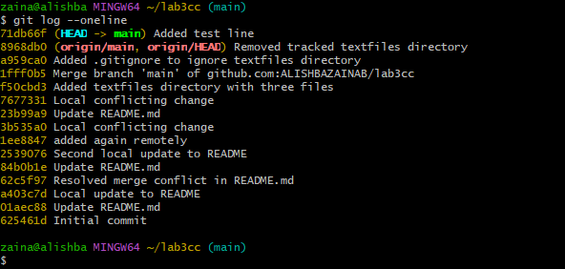

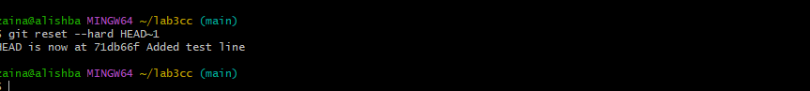

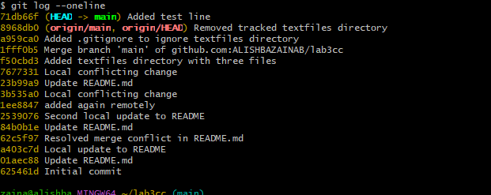

Task 7

**Amending the Last Commit**

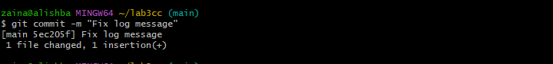

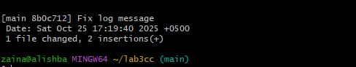

Task 8

**Reverting a Commit (Safe Undo on Remote Branch)**

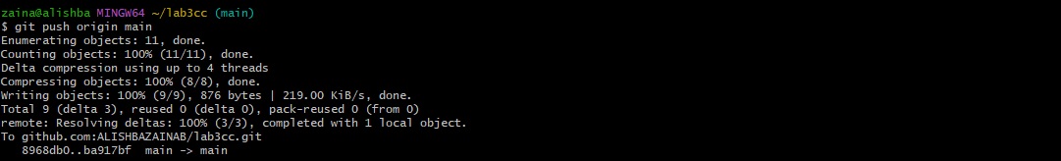

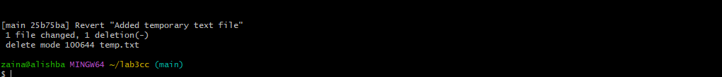

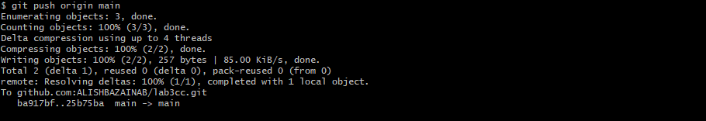

Task 9

**Force Push (With Caution)**





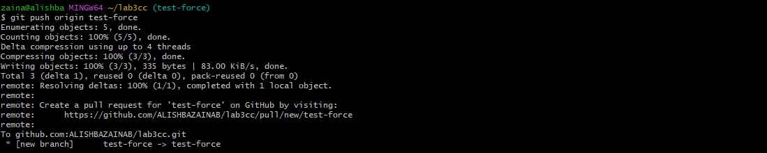



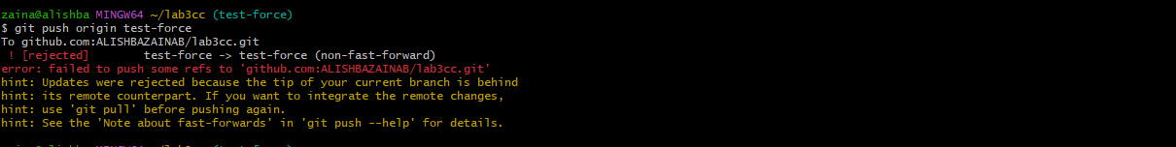



Task 10

**Running Gitea in GitHub Codespaces via Docker Compose**

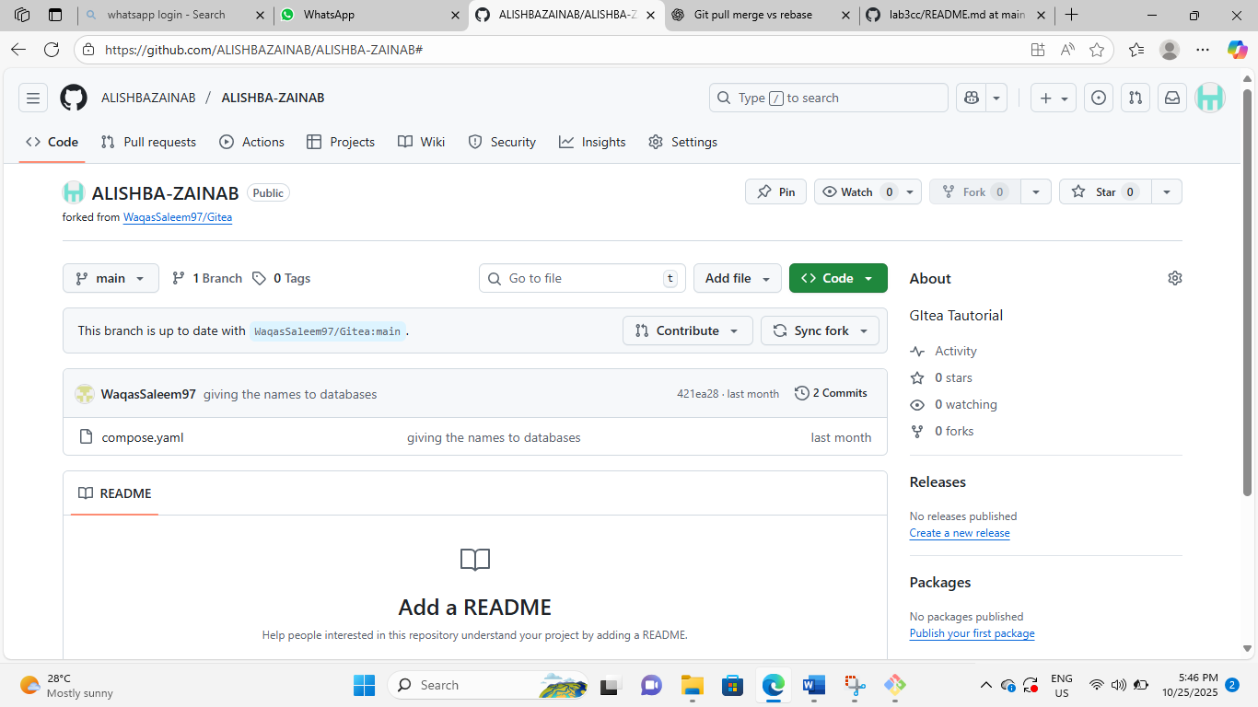

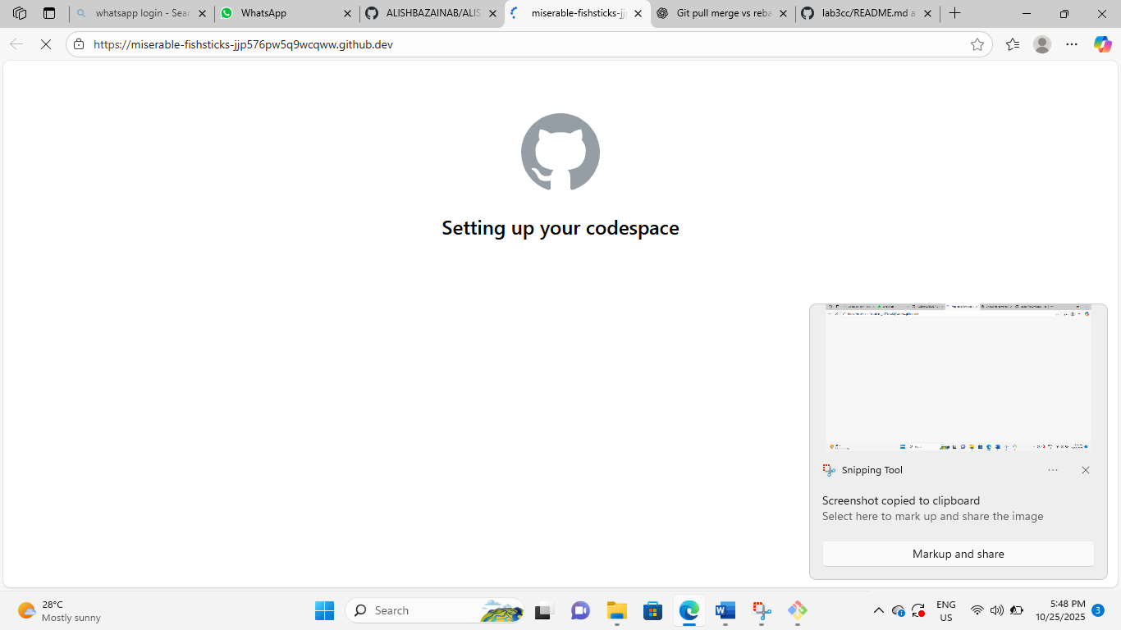

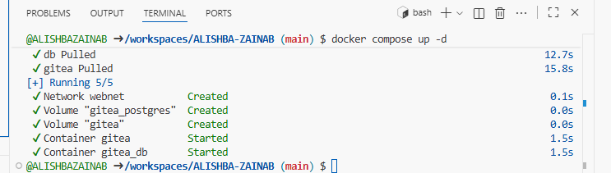

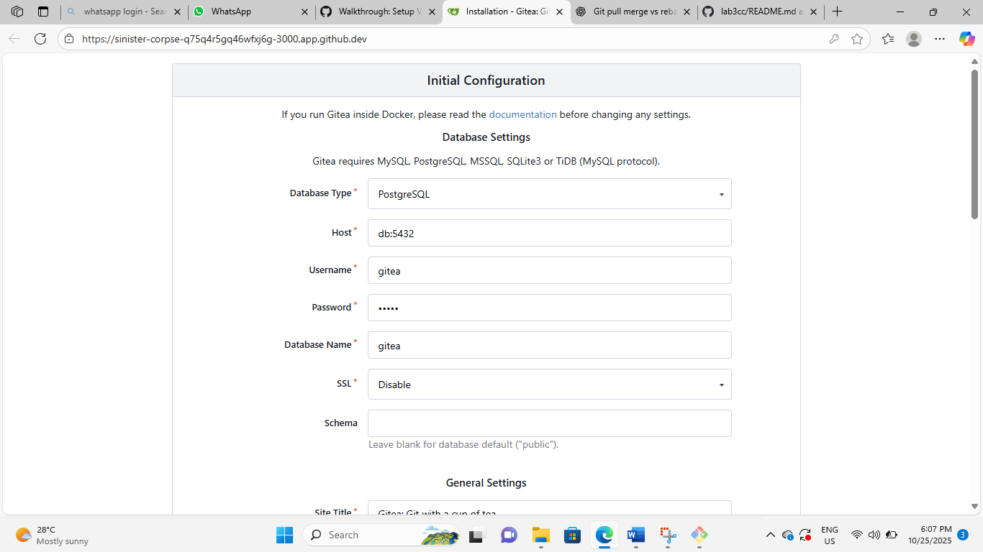

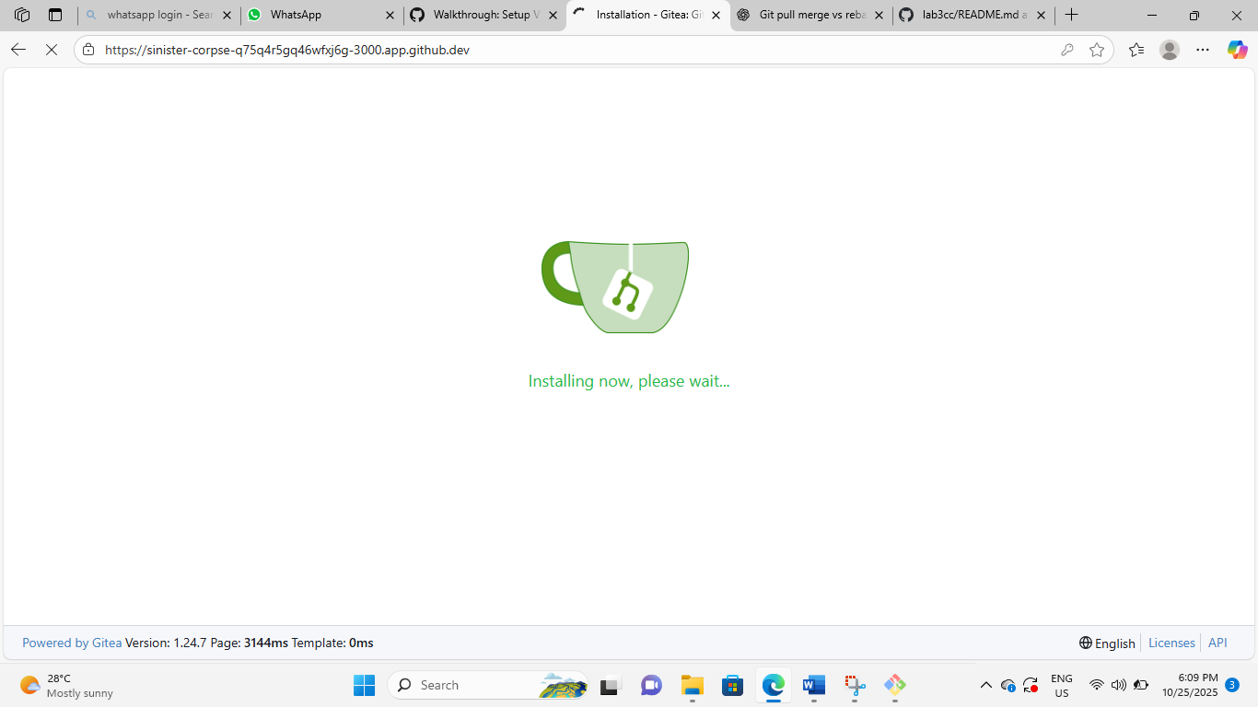

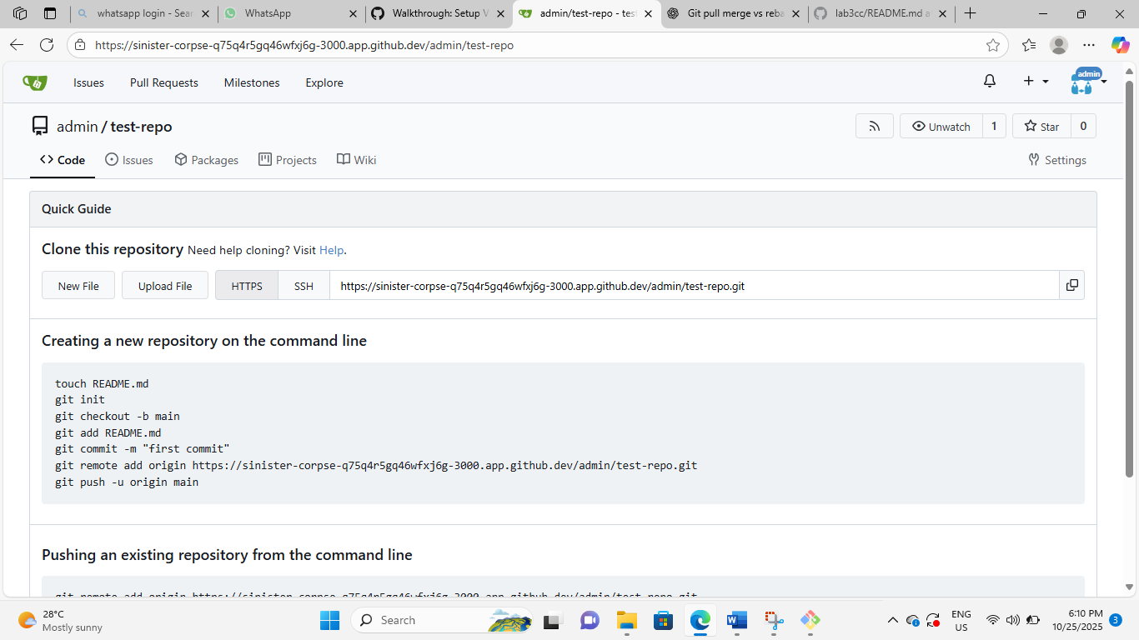

Task 11

**Creating a GitHub Pages Portfolio Site**

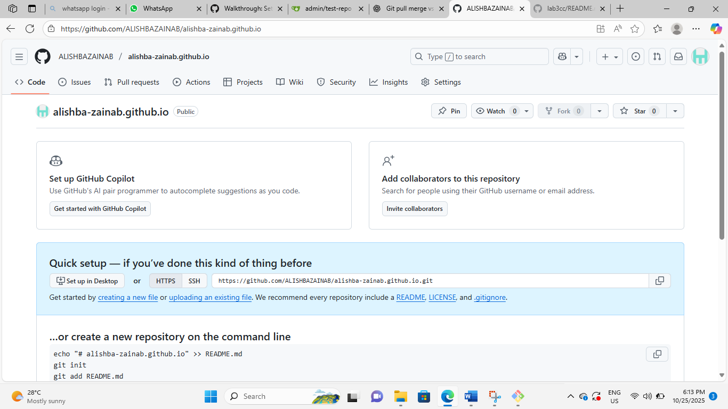

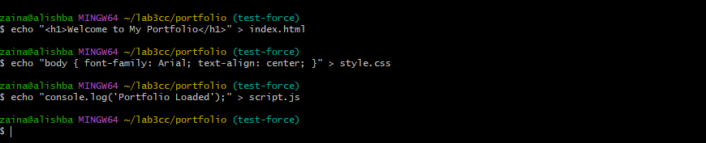

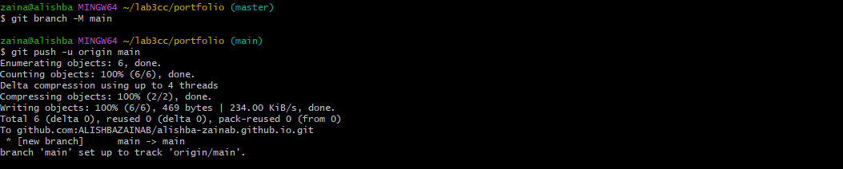

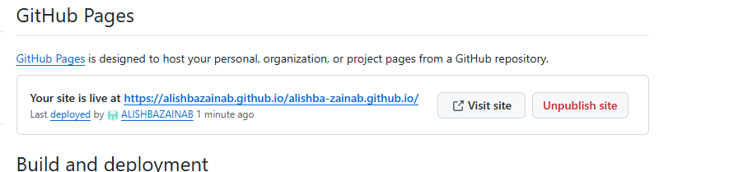

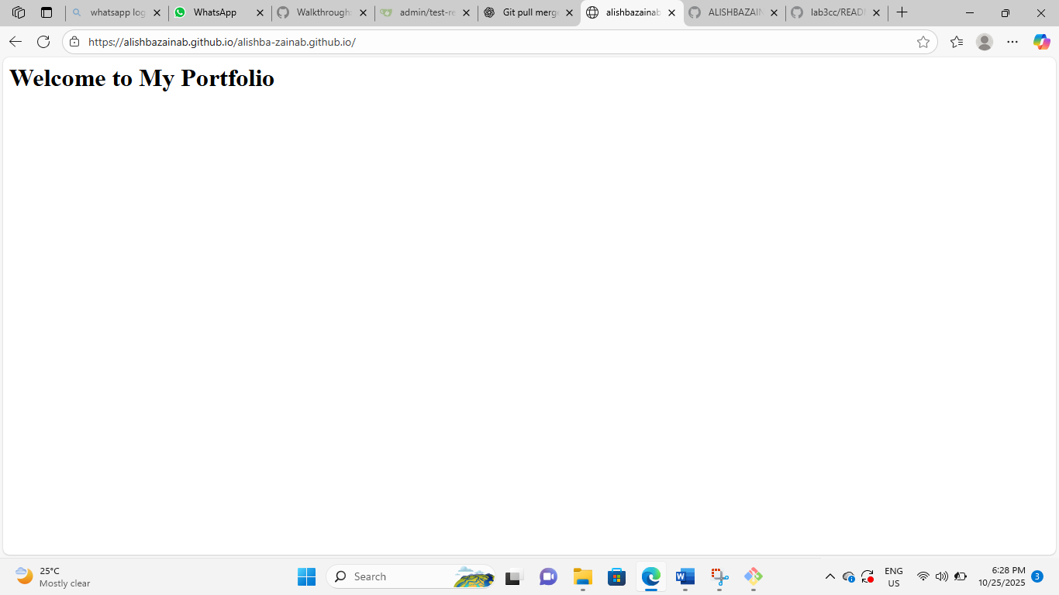

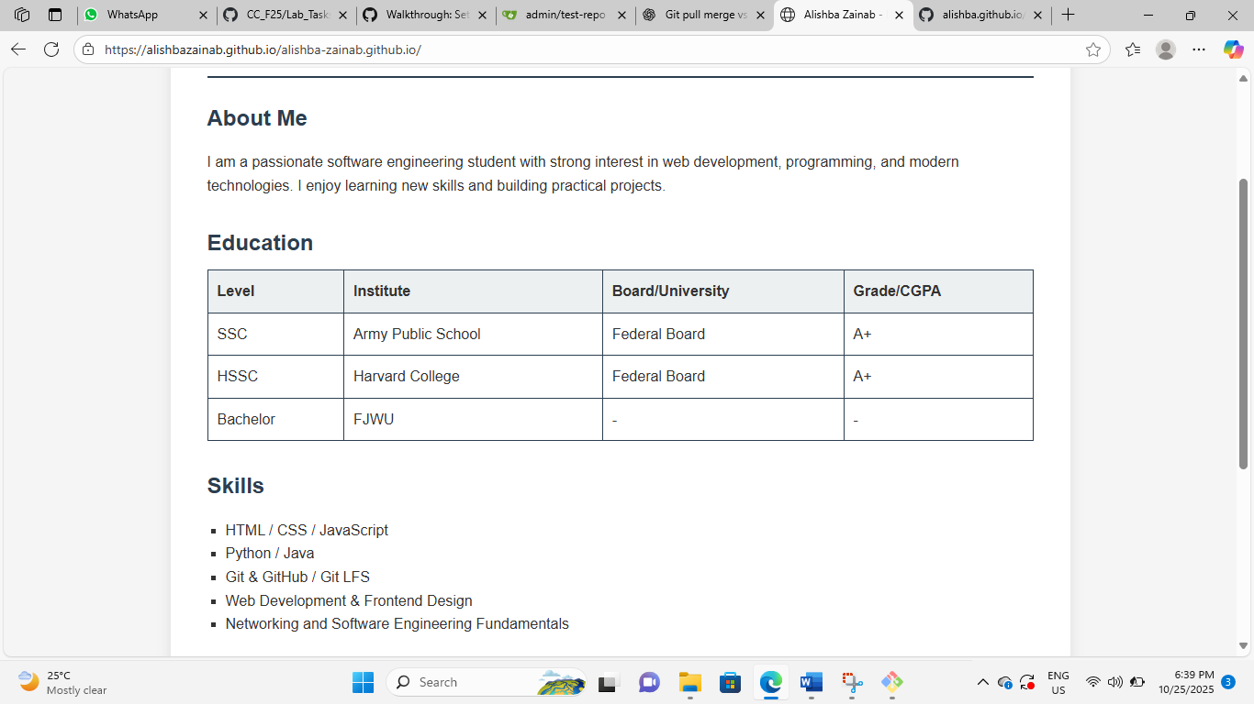

Evaluation questions

Question 1

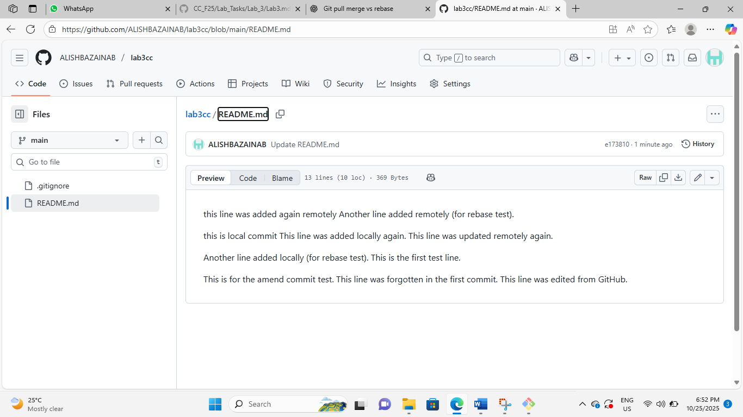

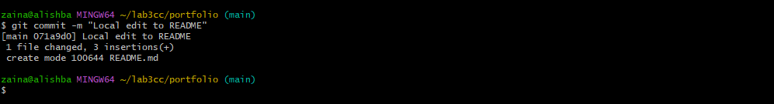







Question 2







Question 3









Question 4











